
SALT LAKE CITY POLICE DEPARTMENT
Lateral Entry Program Application

Name: Date of Application:

Date of Category I Police Officer Certification:

Please include the following with your application:
- Attach a verification of employment letter (if applicable) for all law enforcement agencies you have worked for. The verification letter must include the following: status of employment (i.e. full-time, part-time, seasonal, etc.), hire date, separation date, and be typed on the agency’s letterhead. Please note specific dates are required: MM/DD/YY.
- Attach a copy of your Category I Police Officer Certificate (If you are an out-of-state candidate please send your out-of-state certificate and your Utah certificate).

Eligibility Requirements:
In-State and Out-of-State Candidates:
- High school diploma or equivalent and at least one full year working in a Law Enforcement Officer (LEO) capacity for an agency whose primary responsibility is responding to calls for service.
- Current Utah Peace Officer Standards and Training (POST) certification as a Law Enforcement Officer. Out-of-state applicants must successfully pass Utah POST Waiver exam.
- Must be a U.S. Citizen; or a lawful resident of the United States who: has been in the United States legally for at least five years; and has legal authorization to work in the United States on/by the date of the first examination.
- Must be at least 21 years old at the time of certification as a special function officer. The Special Function Officer block is held during the first eight weeks of the police academy.
- Graduation from the Salt Lake City Police Academy within six (6) months of hire.
- Considerable human relations skills and communications skills.
- Ability to work independently, make critical decisions, and use initiative and common sense.
- Must be able to render credible testimony in a court of law.
- Must have valid state driver’s license or Utah driving privilege card (or the ability to obtain one within 30 days of employment).

Program Guidelines:

The following program guidelines have been established as prescribed by the Chief.

Upon successful completion of all stages in the testing process the Lateral Entry Program will include the following:

- Compensation credit given for prior experience as a Category I Police Officer with any public law enforcement agency on a month-for-month basis (up to 12 years).
- Vacation and personal leave credit given for prior experience as a Category I Police Officer with any public law enforcement agency on a month-for-month basis (up to 12 years). Additional time awarded for prior Salt Lake City Corporation employment.
- No credit would be given for less than 1 year (12 months) of law enforcement experience as a Category I Police Officer. Credit is only counted by every full month of completed service.
- Candidates would be required to complete the full or abbreviated Salt Lake City Police Academy, as requested. Candidates are paid their lateral entry salary while attending the Police Academy.

Wage:
As a lateral candidate you will receive compensation on a month-for-month basis for every full month of service you have working as a Category I Police Officer (up to 12 years).

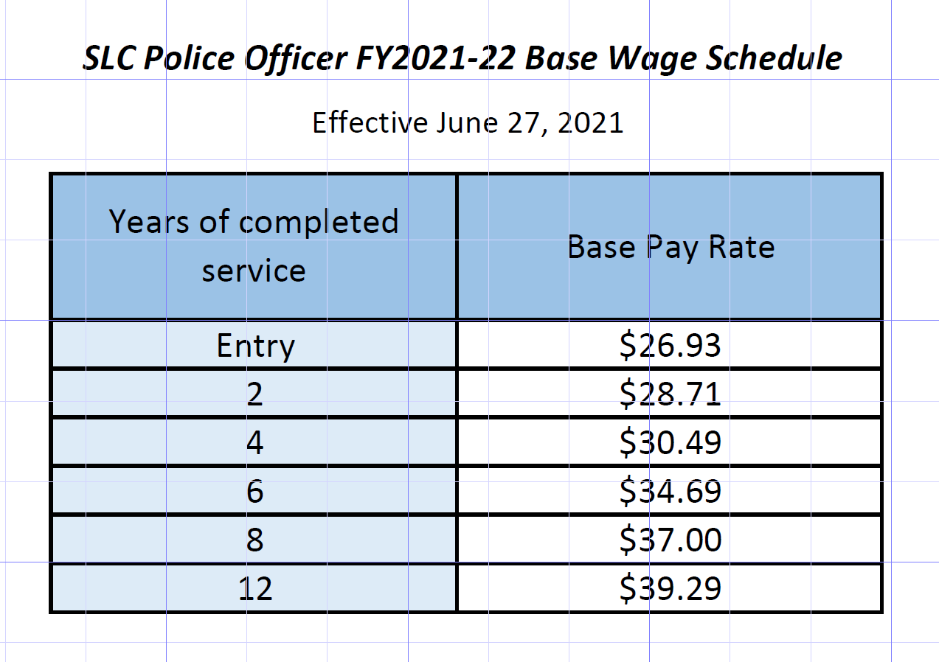

Vacation and Personal Leave:
As a lateral candidate you will receive vacation and personal leave on a month-for-month basis for every full month of service you have working as a Category I Police Officer (up to 12 years).
If you have previous employment with Salt Lake City Corporation, your vacation accrual is based on your total years of Salt Lake City employment.

Vacation Schedule

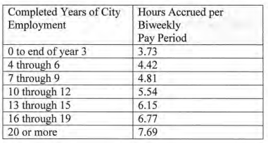

Personal Leave Schedule

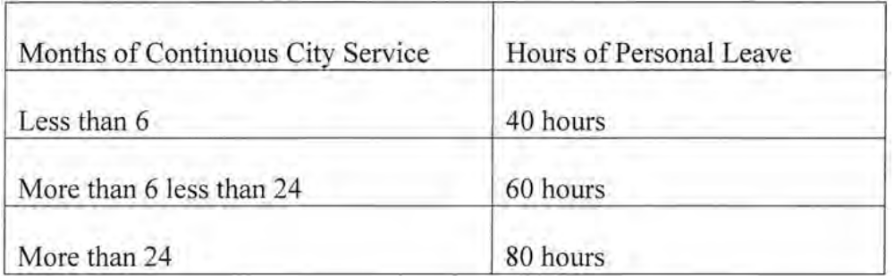

Seniority:
Credit for prior years of service under the Lateral Entry Program shall not apply to the computation of longevity pay or departmental seniority.

Departmental seniority will be established by an identification number assigned to Police Officers by the department upon successful completion of initial training. Police Officers will be shifts, days off, and where applicable, specific patrol districts or Division work assignments by departmental seniority when a conflict does not exist with departmental policy or operating efficiency.

I authorize that I have read and understand the terms of the Salt Lake City Police Department Lateral Entry Program as outlined above.

______________________________ ___________________________
Candidate Signature Today’s Date

For Internal Office Use Only:

Agency: _____________________________________________
Date of Hire: _________________________________________
Date of Separation: _____________________________________
Verified by: ___________________________________________

Agency: _____________________________________________
Date of Hire: _________________________________________
Date of Separation: _____________________________________
Verified by: ___________________________________________

Agency: _____________________________________________
Date of Hire: _________________________________________
Date of Separation: _____________________________________
Verified by: ___________________________________________

